**ITSE 1330 – Intro to C#**

**Module 6 - Project 6**

**There are 2 projects for this Module. Place both project folders in a folder called FirstnameLastnameCSMod6. When you are done with both projects, zip the folder and submit via Moodle. DO NOT ZIP EACH INDIVIDUAL PROJECT, only the outer folder.**

*Create a Windows Forms application named* ***FirstNameLastName6A***

*Save the application in the FirstnameLastnameCSMod6 folder.*

In the Project 6 resources folder in moodle, there is a file named Sales.txt. The image below shows the file’s contents displayed in Notepad.

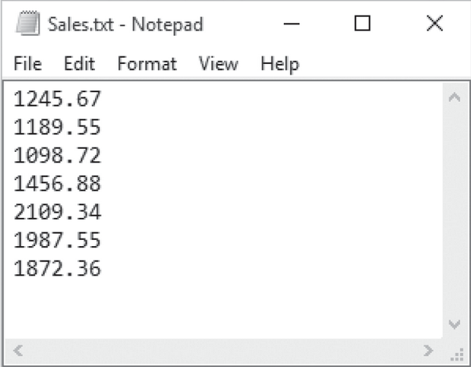

Create an application that reads this file’s contents into an array on form load and displays the array’s contents in a ListBox control. There should also be a working Exit button. Use a method somewhere in the program.

There should be a Sales button that calculates and display the following in labeled labels:

The total of the array’s values.

The average of the values in the array

The largest value in the array

The smallest value in the array

Example Form:

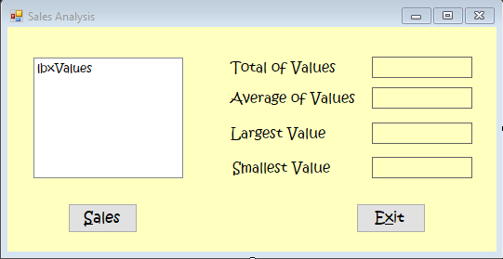

*Create a Windows Forms application named* ***FirstNameLastName6B***

*Save the application in the FirstnameLastnameCSMod6 folder.*

In the Project 6 resources folder in moodle, there are 2 text files you will be using for this project.

Teams.txt—This file contains a list of several Major League baseball teams in alphabetical order. Each team listed in the file has won the World Series at least once.

WorldSeriesWinners.txt—This file contains a chronological list of the World Series’ winning teams from 1903 through 2012. (The first line in the file is the name of the team that won in 1903, and the last line is the name of the team that won in 2012. Note that the World Series was not played in 1904 or 1994.)

Create an application that displays the contents of the Teams.txt file in a ListBox control on form load. When the user selects a team in the ListBox, the application should display (in a label) the name of the team and the number of times that team has won the World Series in the time period from 1903 through 2012.

Hint…Read the contents of the WorldSeriesWinners.txt file into a List or an array. When the user selects a team, an algorithm should step through the list or array counting the number of times the selected team appears.

Add a working Exit button.

Example Form:

